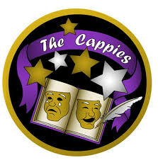
Cappies Gala Singer Auditions 2020
Want to experience performing on the Kennedy Center stage for a televised sold-out crowd on the Orchestra Hall Stage on Sunday, May 31, 2020?
Audition to be a PRESTIGIOUS Gala Singer!

Audition Requirements:
- Complete a video of yourself performing 2 minutes or less of a musical theatre or Disney song
- please state your full name & usual voice part for the camera
- a neutral background is better than a busy one (blank wall vs. busy curtains)
- If you don’t have someone to hold the camera while you sing please place it at eye level or slightly above.
- Complete the electronic audition form & upload your video using the link below:
https://form.jotform.com/200064101384137
Auditions must be submitted by March 15, 2020
late submissions will not be considered
Casting notifications will be made via email by April 1st.

Rehearsals will be held on Saturday mornings 9-12 at:
St. Stephens and St. Agnes School (4/18 and 5/2) and Fairfax HS (5/16).
Dress rehearsal will be in the morning of 5/30 at Hayfield SS.

All rehearsals are mandatory. Please consider your availability before submitting your audition.
Questions? Email Emi Eiting, vocal director at emi.eiting@cappies.org.

