Musical Theatre Audition 101 Workshop & Master Class
October 21, 2014
6:00-8:00 PM Chorus Room

What you will learn:
- How to select appropriate music to showcase vocal range and acting abilities
- How to make a good16/32 bar cut
- Audition preparedness skills
- Simple audition empowerment tips and tricks
- How to be in control of your audition
- How to "act" a song
- Acting with intention not indication

Want even more? Perform at the workshop and get an instant coaching from Jenny to prepare for your upcoming Broadway Night audition:
- Come prepared to sing 32 bars of a Broadway style Up-tempo or Ballad that you know well
- Professional accompanist will be provided
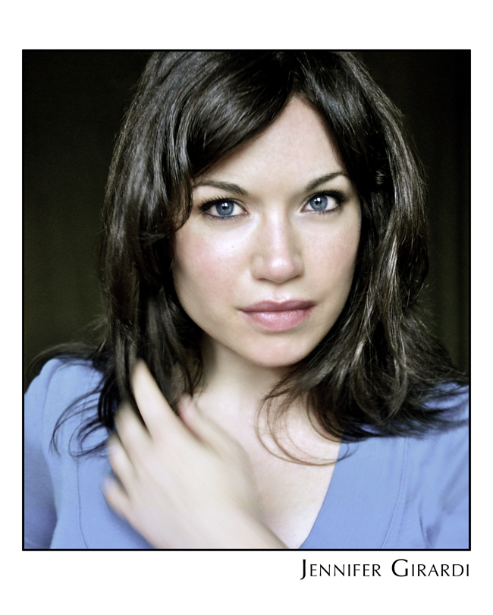
Jenny has been performing all over the DC area since her youth and received her B.A. in theatre from George Mason University with a concentration in acting. She studied classical ballet and modern dance and the Classical Ballet Academy and at George Mason University, and studied with the Mark Morris Dance Company and the Joffrey Ballet while living in NYC.
While at GMU, she participated in the Kennedy Center's Page to Stage Festival and spent a semester abroad studying Theatre in London's West End as well as performing in Edinburgh's Fringe Festival. In New York, Jenny studied under Maggie Flanigan at The Maggie Flanigan Studio and was accepted into William H. Macy's Atlantic Acting School's conservatory program before moving to Italy where she ran workshops for artists on the Amalfi Coast. In the DC area, Jenny has taught acting, improv and movement at Dodgeball Theatre, acting and Broadway dance at the Classical Ballet Theatre and has choreographed for High Schools in Northern VA. TV credits include The Good Wife, Boardwalk Empire, 30 Rock and Gossip Girl. Favorite roles include Cinderella in Cinderella, Catherine in Proof, Julie in Pizza Man and Christine in Phantom.

